38.60: a) The change in wavelength of the scattered photon is given by Eq. 38.23
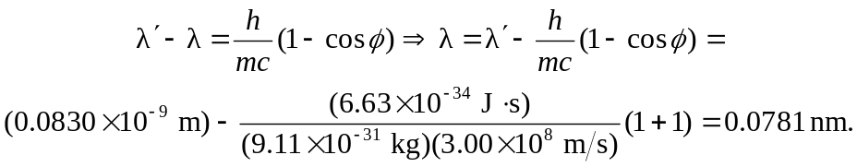
b) Since the collision is one-dimensional, the magnitude of the electron’s momentum must be equal to the magnitude of the change in the photon’s momentum. Thus,
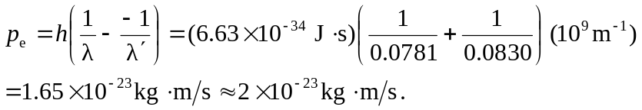
c) Since the electron is non relativistic 